花蓮縣111國小英語寫作比賽題型示例

Examples for 2018 English Composition/Writing Contest

for Elementary School Students (國小寫作比賽)
- Picture Writing看圖寫作 (100%) Please write a short story for each picture. You need to use the words in the word bank for each picture. 40-50 words for each picture.

    - 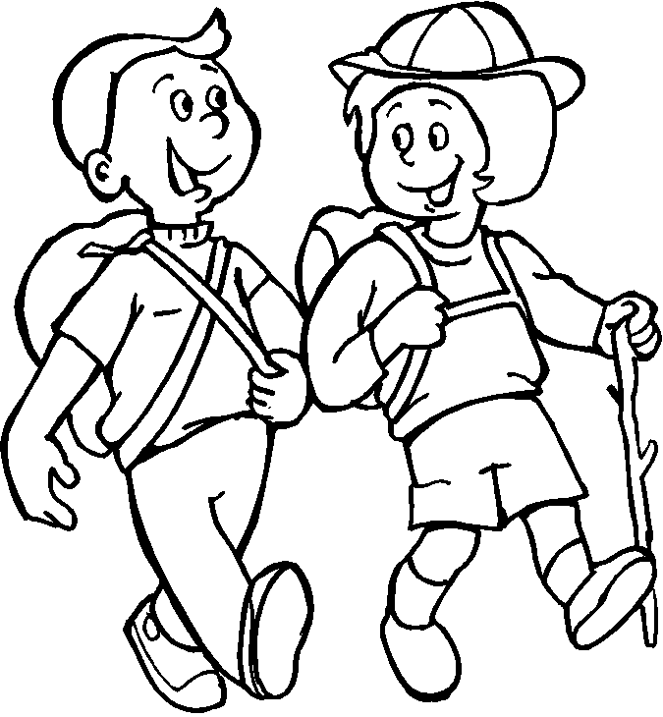
    - 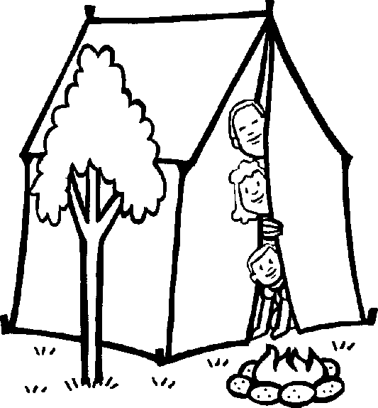

    - 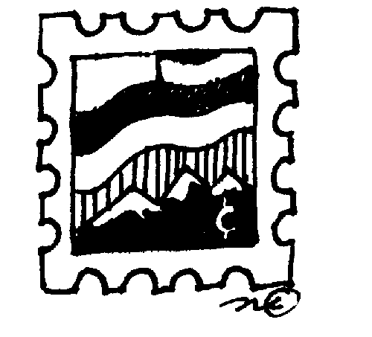
Example Answers for Picture Writing: Answers will vary.---共4個圖。

