- Time: 2011/06/08 08:30-12:00
- School: Rui-Sui Junior High School
- Participants: 25 students/teachers from Cumbria,
15 students from Rui-Sui
Chin Hsiu-Ling(Principal of Rui-Sui Junior High School),
Yang Chu-Ya(Sharo), and
Chen Chia-Yi(Joy)
Time | Activity | Place | Students |  | Notes
08:30-10:00 | *Welcome dance  迎新舞蹈表演  *Talent Show  才藝表演 | Auditorium育樂館 | Rui-Sui | Cumbria | *you can also give us a show if you are willing to
08:30-10:00 | *Welcome dance  迎新舞蹈表演  *Talent Show  才藝表演 | Auditorium育樂館 | 6 for aboriginal dance | 25 | *you can also give us a show if you are willing to
10:00-11:00 | *Meet your partners  認識同伴  *Leather carving  皮雕製作 | Library  圖書館 | Mix all the students together (15 from Rui-Sui and 25 from Cumbria), make eight new groups with 2 students from Rui-Sui and 3 students from Cumbria in each group.  混合所有學生分成8組,  每組5人  (瑞中2人+ Cumbria 3人) |  | *a key ring
11:00-12:00 | *School Fair  園遊會 | On campus校園 | as above |  | *coupon
12:00 | *Lunch Time | Library  圖書館 |  |  | *Bento
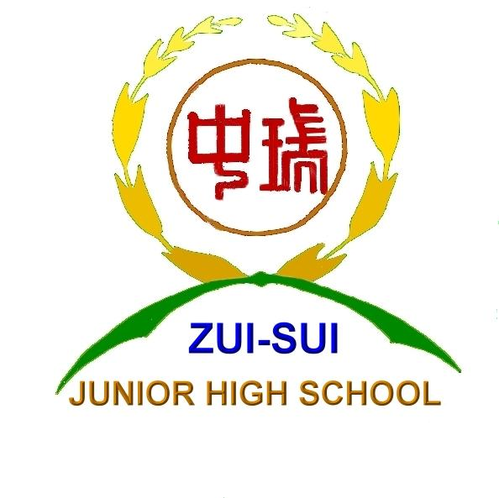




Welcome to Rui-Sui Junior High School

