**110年學力檢測題本**

**英語文七年級**

作答注意事項：

各位同學：

你們好。

這是一份英語文的試題，總共35題。

第一個部分是15題聽力能力檢測，

第二個部分是20題閱讀能力檢測。

測驗時間為45分鐘。

每一題請選**一個最合適的答案**，並用2B鉛筆在答案卡畫記，不可超出格線外，如果需要修改答案，請用橡皮擦擦拭乾淨，再重新畫記。

畫記說明：

當你想選擇的答案為②時，正確畫記為 ① ● ③ ④

其他事項：

* 每一題都要回答。
* 試題如有錯誤，請立即告知老師。

|  |  |
| --- | --- |
| 學 校 |  |
| 班 級 |  |
| 姓 名 |  |
| 座 號 |  |

**110年學力檢測題本**

**英語文七年級聽力及閱讀測驗**

各位同學，我們將要進行英語的聽力測驗和閱讀能力測驗。第一部分是聽力測驗共三大題，每一題都會先說明作答方式，請注意試題本上的例題，錄音說明完才會開始播放考試的題目。

每題會播放兩遍，題目不在試題本上，請依照聽到的內容，並看到各題的四個選項中，選出一個正確或最佳的答案，並畫記在答案卡上。錄音唸下一題時，你就要跟著做下一題。錄音會帶著你做完所有的聽力題目。開始作答後，請自行完成測驗，監考老師不會回答任何問題。但是你如果感覺身體不舒服，可以舉手向監考老師反應。

**現在請翻頁。聽力測驗即將開始，請安靜並專心作答。**

**第一部分：聽力能力檢測，共三大題，15小題。**

**第一大題：辨識句意（第1-3題）**

**作答說明：請依據所聽到的句子，選出符合描述的選項，每題播放兩次。**

|  |  |  |  |  |
| --- | --- | --- | --- | --- |
| 示例題：你會看到   |  |  | | --- | --- | |  |  | |  |  |   然後你會聽到．．．．．（播音）。依據所播放的內容，正確答案應該選，請將答案卡該題「」的地方塗黑、塗滿：即 ● |

|  |  |  |  |
| --- | --- | --- | --- |
| ① | ② | ③ | ④ |
| No Camera 图片、库存照片和矢量图| Shutterstock | Grade 3, Lesson 10 - Don't Run - The ESL Toybox | Turn off that cell phone | No Ban or Stop signs Light lamp icons Royalty Free Vector |

|  |  |
| --- | --- |
| ① | ② |
|  |  |
| ③ | ④ |
|  |  |

|  |  |  |  |
| --- | --- | --- | --- |
| ① | ② | ③ | ④ |
|  |  |  |  |

**第二大題：基本問答（第4-8題）**

**作答說明：每題均有四個選項，請依據所聽到的內容，選出一個最適合的回應，每題播放兩次。**

|  |
| --- |
| 示例題：你會看到  ① Yes, I am angry.  ② No, I am happy.  ③ Yes, I want a hamburger.  ④ No, this is not a hamburger.  然後你會聽到．．．．．．（播音）。依據所播放的內容，正確答案應該選③，請將答案卡該題「③」的地方塗黑、塗滿：即 ①②●④ |

1. It’s on May fourth.
2. It’s eleven twenty.
3. It’s on the weekend.
4. It’s in the morning.
5. No problem.
6. Come on!
7. Hurry up.
8. Don’t worry.
9. I like making coffee.
10. I like to drink.
11. Milk tea, please.
12. Sure. I am ready.
13. They’re going away.
14. They are from America.
15. They’re my favorite gift.
16. They’re right there on your head.
    1. I don’t know his name.
    2. E-L-I-Z-A-B-E-T-H.
    3. My name is Sharon.
    4. Her name is from my grandma.

**第三大題：言談理解（第9-15題）**

**作答說明：每題均有四個選項，請依據所聽到的對話或短文內容，選出一個最適合的答案，每題播放兩次。**

|  |
| --- |
| 示例題：你會看到  ① Thursday.  ② Friday.  ③ Saturday.  ④ Sunday.  然後你會聽到．．．．．．（播音）。依據所播放的內容，正確答案應該選③，請將答案卡該題「③」的地方塗黑、塗滿：即 ①②●④ |

1. In his home.
2. In the church.
3. In the library.
4. In the hospital.

① At school.

② At a restaurant.

③ At a bookstore.

④ At a clothes store.

1. Number 635.
2. Number 653.
3. Number 563.
4. Number 356.
5. The man’s socks.
6. The trash can.
7. The sofa.
8. The kitchen.

① Stay at home and watch TV.

② Get some sleep at home.

③ Go swimming with the man.

④ Drive to the swimming pool.

1. Take the dog for a walk.
2. Go swimming together.
3. Give the dog some food.
4. Play the ball with the dog.

① Feed the monkeys

② Touch the monkeys.

③ Shake the monkeys’ hands.

④ Take photos with the monkeys.

**各位同學，聽力測驗已經完成了，下一大題開始為閱讀測驗。**

**現在請翻到下一頁繼續完成作答。**

**第二部分：閱讀能力檢測，共2大題、20小題。**

**第一大題：單題（第16-22題）**

1. Look at the picture. What is the girl wearing?

① She is wearing a hat.

② She is wearing a vest.

③ She is wearing a coat.

④ She is wearing a dress.

1. James is __________ cooking. He can cook many delicious dishes.
2. bad at
3. nice to
4. good at
5. afraid of
6. Patty loves fruit. Apples are her __________. She eats one apple every day.
7. ready
8. special
9. favorite
10. famous
11. Gina: __________ it rainy in Taiwan in winter?  
    Alice: No, it’s sunny.
12. Is
13. Do
14. Am
15. Does
16. Ken is a 14-year-old boy. Like most teenagers, he __________ his cellphone every day.
17. use
18. uses
19. is using
20. are using
21. The Lin family want to go on a picnic. When can they go?

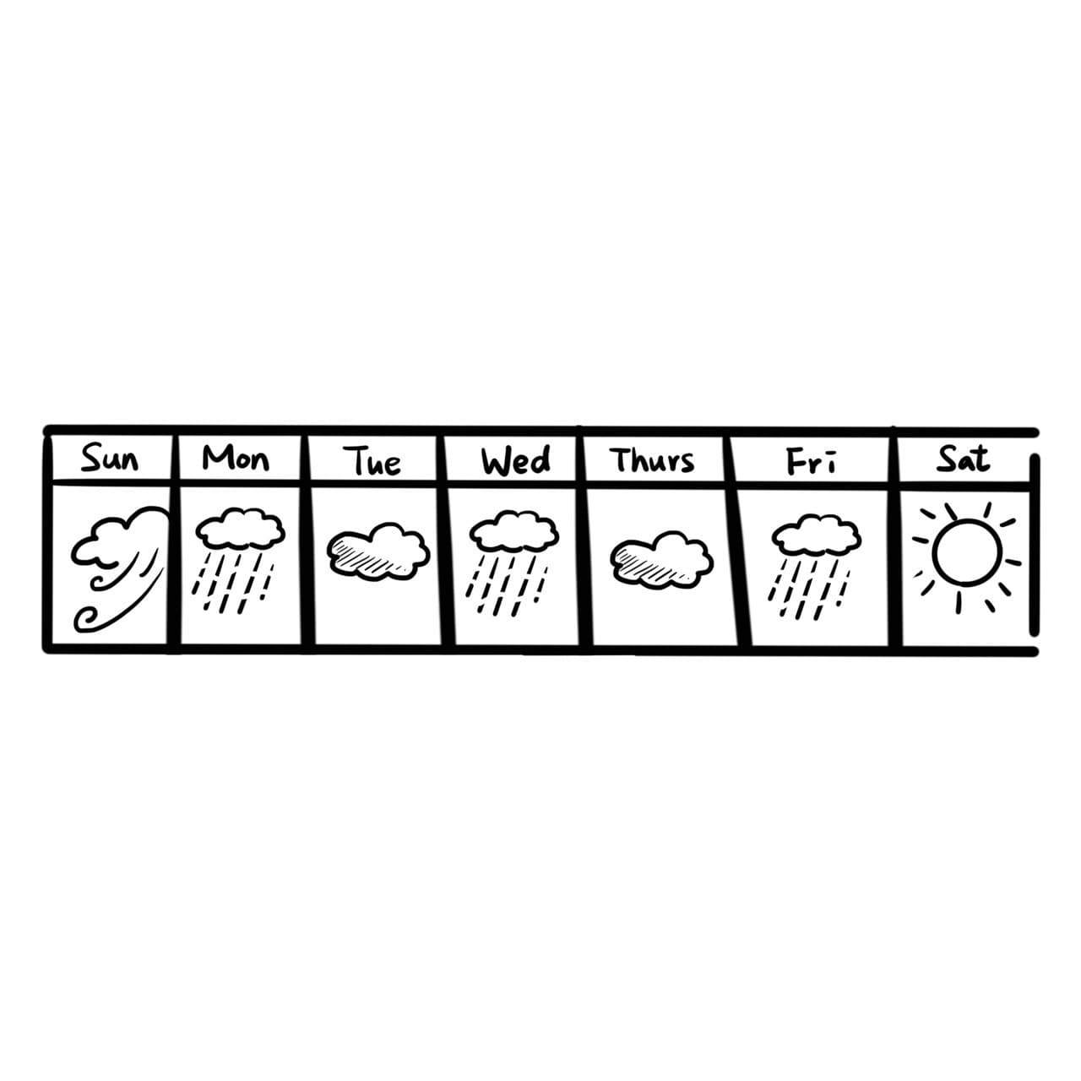

① Friday.

② Sunday.

③ Tuesday.

④ Saturday.

1. Here is Laura’s to-do list. What is her job?

1. Buy some vegetables in the supermarket.

2. Clean the living room at 10 am.

3. Wash Mandy’s and Peter’s winter coats in the afternoon.

4. Drive Mandy to dance class at 4:00 pm.

5. Cook dinner at 5:30 pm.

1. Singer.
2. Baker.
3. Housewife.
4. Businessman.
5. Peter and Rita are chatting on LINE. Peter and Rita are _______.

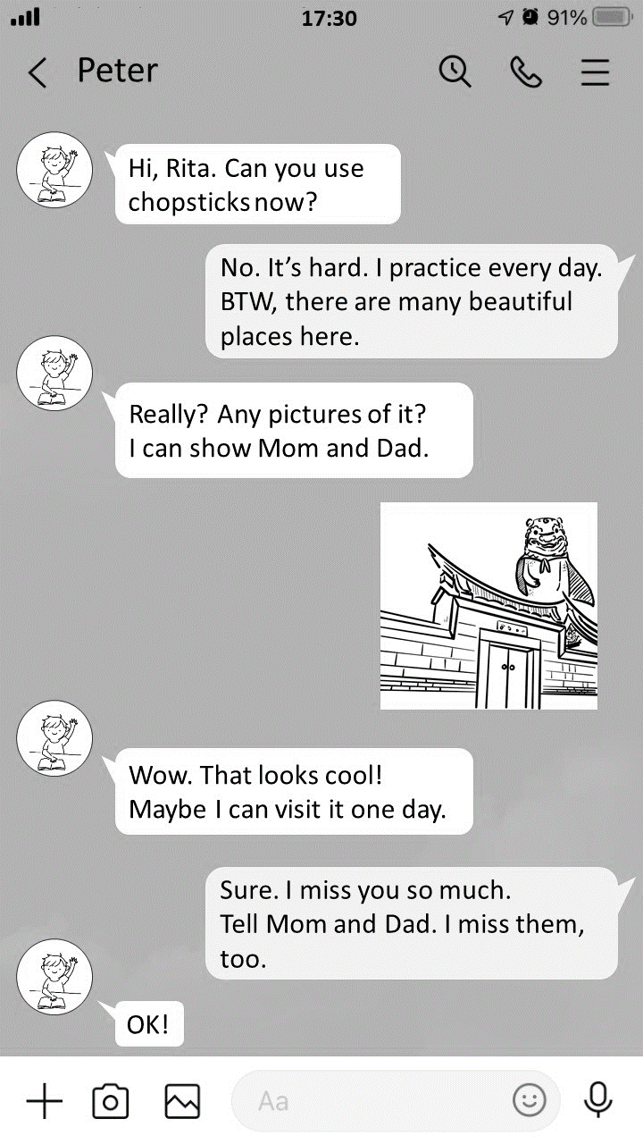

1. mother and son
2. brother and sister
3. father and daughter
4. grandfather and granddaughter

**第二部分：題組（第23-35題）**

◆**(24-28)**

|  |
| --- |
| Good evening, everyone. This is Nancy speaking from NCC news.  It is seven-forty p.m. on Friday night. Look! There are many people 24 for their favorite band, Mayday, in front of Taipei Arena. There are five people in the band, Monster, Ashin, Stone, Masa and Guan You. Although 25 , they are still popular with people around the world. Their songs are great and their 26 are usually full of people. Look! Monster and Stone are playing the guitars. Masa is playing the bass guitar, and Ming is playing the 27 . Their fans are singing and dancing with Ashin. Everyone is 28 . It’s a great night.  🕮 Taipei Arena台北巨蛋 Mayday五月天 Although雖然 are full of充滿著 bass貝斯 |

1. lining up
2. taking up
3. looking up
4. climbing up
5. Mayday likes music
6. Mayday’s fans are girls
7. Mayday’s songs are cool
8. Mayday are from Taiwan
9. rooms
10. letters
11. houses
12. concerts
13. balls
14. dolls
15. drums
16. games
17. shy
18. tired
19. happy
20. angry

◆**(29-32)**

|  |  |  |  |  |  |  |  |  |  |  |  |  |  |  |  |  |  |  |  |  |  |  |  |  |  |  |
| --- | --- | --- | --- | --- | --- | --- | --- | --- | --- | --- | --- | --- | --- | --- | --- | --- | --- | --- | --- | --- | --- | --- | --- | --- | --- | --- |
| Jeff : Good evening, everyone. I am Jeff, a reporter for Changhua Food News. I am at Jing Cheng Night Market now. There are so many people and vendors here. Look! Here is a map. I am in front of the beef noodles stand. There is a stinky tofu stand behind it. I see my favorite stand, the oyster omelet stand. It is between the ice cream stand and the pearl milk tea stand. Now, let’s talk to some of the people here.  (Jeff is interviewing a woman.)   |  |  | | --- | --- | | Jeff: | Good evening. I’m Jeff, a food reporter. What have you got there? | | The woman: | It’s stinky tofu. | | Jeff: | Is it good? | | The woman: | I don’t know. It is from my friend. The smell is bad. I’m afraid to eat it. | | Jeff: | Well, just take a bite. You will love it. | | The woman: | Ok, I will try! |   (Jeff is interviewing a man.)   |  |  | | --- | --- | | Jeff: | Good evening, Sir. What’s your name? | | The man: | I am Ken. | | Jeff: | What food can you cook? | | The man: | Bruschetta. | | Jeff: | Please tell me something about it. | | The man: | It is a famous snack from my home country, Italy. There are tomatoes, cheese, and vegetables on the top of toasted bread. You can try it. | | Jeff: | Wow! It’s so great! Thanks a lot! |   🕮 vendor攤販 stand攤位 interview採訪 am afraid to害怕 let you down讓你失望 |

1. Which one is the map of the night market?

|  |  |
| --- | --- |
| ① | ② |
| **L**  **L** | **L** |
| ③ | ④ |
| **L** | **L** |

1. What does it refer to in the interview with the woman? 🕮 refer to 意指
2. The friend.
3. The woman.
4. Bruschetta.
5. Stinky tofu.
6. What does “take a bite” mean in the dialogue?
7. try it
8. buy it
9. read it
10. save it
11. Where is Ken from?
12. Italy.
13. Japan.
14. Taiwan.
15. America.

◆**(33-35)**

|  |
| --- |
| 🕮 vegetarian 素食者 |

1. What **CAN’T** you buy from Granny’s Restaurant?
2. Chicken burgers.
3. Apple juice.
4. Banana cakes.
5. Chicken pizzas.
6. Sandra is a vegetarian. What can she eat at Granny’s Restaurant?
7. Four cheeses pizza.
8. Seafood salad and tea.
9. Fish and mushroom pie.
10. Chicken curry with rice.
11. It’s 8:30 p.m. David and his friends are at Granny’s Restaurant. They have two glasses of apple juice, three cheeseburgers, and a plate of mixed fruits. How much should they pay? 🕮 pay付錢
12. 60
13. 140
14. 200
15. 220