**110年學力檢測題本**

**英語文六年級**

作答注意事項：

各位同學：

你們好。

這是一份英語文的試題，總共35題。

第一個部份是15題聽力能力檢測，

第二個部份是20題閱讀能力檢測。

測驗時間為40分鐘。

每一題請選出一個最合適的答案，並用2B鉛筆在答案卡畫記，不可超出格線外，如果需要修改答案，請使用橡皮擦擦拭乾淨，再重新畫記。

畫記說明：

當你想選擇的答案為時，正確畫記為① ② ③ ●

其他事項：

* 每一題都要回答。
* 試題如有錯誤，請立即告知老師。

|  |  |
| --- | --- |
| 學 校 |  |
| 班　級 |  |
| 姓　名 |  |
| 座　號 |  |

**110年學力檢測題本**

**英語文六年級聽力及閱讀測驗**

各位同學，我們將要進行英語的聽力測驗和閱讀能力測驗。

第一部分是聽力測驗，

會先說明作答方式，請注意試題本上的例題，錄音說明完才會開始播放考試的題目。每題會播放兩遍，題目不在試題本上，請依照聽到的內容，並看到各題的四個選項中，選出一個正確或最佳的答案，並畫記在答案卡上。

錄音唸下一題時，你就要跟著做下一題。錄音會帶著你完成所有的聽力題目。

開始作答後，請自行完成測驗，監考老師不會回答任何問題。

但是你如果感覺身體不舒服，可以舉手向監考老師反應。

現在請翻頁。聽力測驗即將開始，請安靜並專心作答。

**第一部分：聽力能力檢測，共15小題。**

**【說明】**

**請根據所聽到的詞彙、句子與敘述，選出最適當或相關的答案與回應。將答案的號碼塗在答案卡上。每一題會重複唸兩次。**

**【例題】**

**聽到單字：rabbits, rabbits**

**看到選項：① snakes ② dogs ③ cats ④ rabbits**

**選出正確答案：④**

**現在請開始作答。**

|  |  |  |  |  |
| --- | --- | --- | --- | --- |
|  | ① boat | ② bite | ③ boot | ④ bought |
|  | ① what | ② which | ③ watch | ④ wait |
|  | ① master | ② matter | ③ maker | ④ metro |
|  | ① count | ② county | ③ country | ④ cowboy |
|  | ① sweater | ② skirt | ③ shorts | ④ shirts |

**6.**

① I go to school by bus and I go home on foot.

② I go to church by taxi and I go home by bike.

③ I go to school by taxi and I go home on foot.

④ I go to church by bus and I go home by bike.

|  |  |  |  |  |
| --- | --- | --- | --- | --- |
| **7.** | ① | ② | ③ | ④ |
|  | **C:\Users\user\Desktop\messageImage_1612863802783.jpg** | **C:\Users\user\Desktop\messageImage_1612345642884.jpg** | **C:\Users\user\Desktop\9-2.jpg** | **C:\Users\user\Desktop\messageImage_1612863812413.jpg** |

**8.**

① I get up at six twenty.

② No, I don’t. I go fishing.

③ I have a sore throat.

④ I play the violin.

**9.**

① Jimmy would like some tea.

② Yes, he is from Japan.

③ She is from Italy.

④ No, she is a teacher.

|  |  |  |
| --- | --- | --- |
| **10.** |  | |
|  | ① | ② |
|  | L:\共用雲端硬碟\110年國小英語科學力檢測相關資料\4-6題本圖檔\學力6_Aggie\8-1.jpg | L:\共用雲端硬碟\110年國小英語科學力檢測相關資料\4-6題本圖檔\學力6_Aggie\8-2.jpg |
|  | ③ | ④ |
|  | L:\共用雲端硬碟\110年國小英語科學力檢測相關資料\4-6題本圖檔\學力6_Aggie\8-3.jpg | L:\共用雲端硬碟\110年國小英語科學力檢測相關資料\4-6題本圖檔\學力6_Aggie\8-4.jpg |

**11.**

① I listen to music after school.

② He does his homework.

③ She watches TV.

④ She walks the dog.

|  |  |  |
| --- | --- | --- |
| **12.** | ① | ② |
|  | L:\共用雲端硬碟\110年國小英語科學力檢測相關資料\4-6題本圖檔\學力6_Vivian\8-1.jpg | L:\共用雲端硬碟\110年國小英語科學力檢測相關資料\4-6題本圖檔\學力6_Vivian\8-2.jpg |
|  | ③ | ④ |
|  | L:\共用雲端硬碟\110年國小英語科學力檢測相關資料\4-6題本圖檔\學力6_Vivian\8-3.jpg | L:\共用雲端硬碟\110年國小英語科學力檢測相關資料\4-6題本圖檔\學力6_Vivian\8-4.jpg |

**13.**

① I’m going to see the dragon boat race.

② I’m going to buy some carnations for my mom.

③ I’m going to have a BBQ party and watch the moon.

④ I’m going on an Easter egg hunt with my brother.

**◆14-15**

**14.**

① They’re going to a shopping mall.

② They are going to a park.

③ They are going to a library.

④ They’re going to a bus stop.

**15.**

① It’s spring.

② It’s summer.

③ It’s fall.

④ It’s winter.

**各位同學，聽力測驗已經完成了，下一大題開始為閱讀測驗。**

**現在請翻到下一頁繼續完成作答。**

**第二部分：閱讀能力檢測，共2大題、20小題。**

**第一大題：字母辨識**

**【說明】**

**選出正確相對應的大小寫字母，並將其號碼塗在答案卡上。共2小題。**

**請開始作答：**

**16. PRIDE**

|  |  |  |  |
| --- | --- | --- | --- |
| ① prlbe | ② pride | ③ qribe | ④ qrlde |

**17. BAND**

|  |  |  |  |
| --- | --- | --- | --- |
| ① bamd | ② danb | ③ band | ④ damb |

**第二大題：字意與閱讀理解**

**【說明】**

**請依單字或圖片選出相對應的答案，並將其號碼塗在答案卡上。共18小題。**

**【例題】**

**看到題目：**

**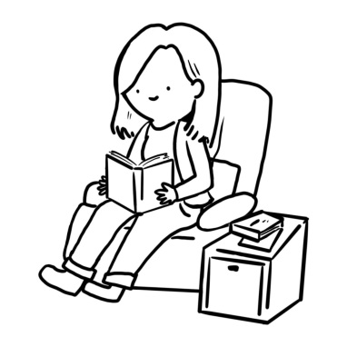**

**看到選項：**

**① read ② write ③ dance ④ sing**

**選出正確答案：①**

**現在請開始作答。**

**18.**

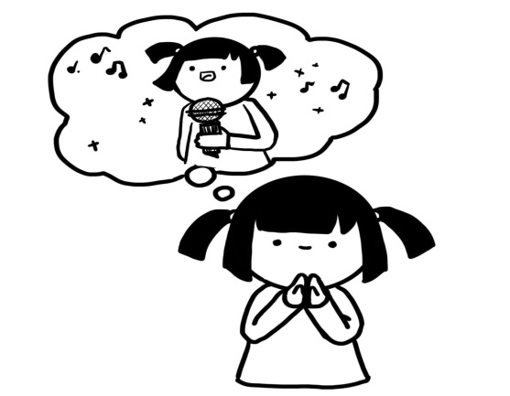

① She wants to be a basketball player.

② She wants to be a doctor.

③ She wants to be an actress.

④ She wants to be a singer.

**19.**

**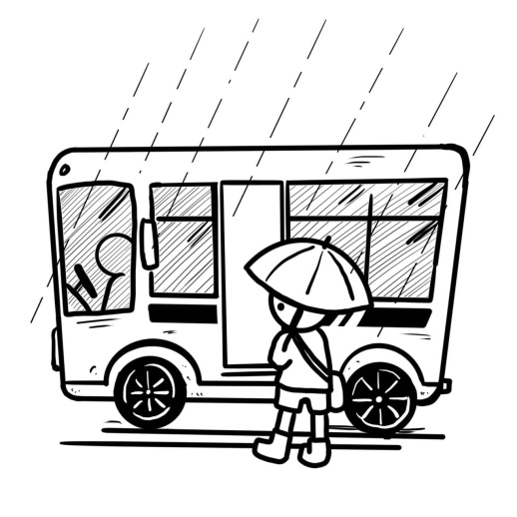**

① It’s sunny. Max goes to school by bus.

② It’s sunny. Max goes to school by bike.

③ It’s rainy. Max goes to school by bus.

④ It’s rainy. Max goes to school by scooter.

**20.**

**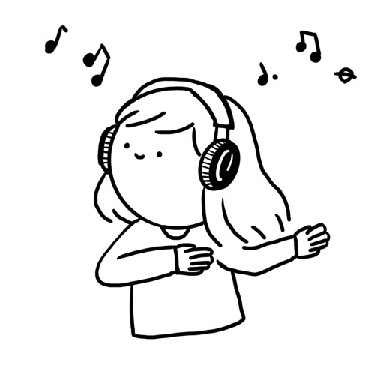**

① She listens to music after school.

② She plays baseball after school.

③ She cooks dinner after school.

④ She rides a bike after school.

**21.**

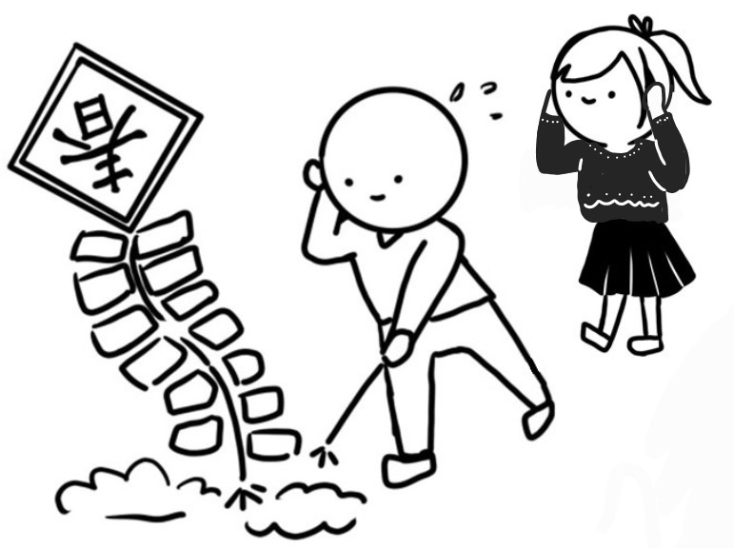

① We go trick-or-treating on Halloween.

② We eat turkey and potatoes on Thanksgiving.

③ We set off firecrackers during Chinese New Year.

④ We eat moon cakes and pomelos on Moon Festival.

**22.**

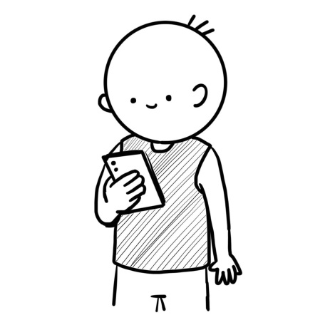

① He is wearing a vest with a cellphone in his hand.

② He is wearing a shirt with a water bottle in his hand.

③ He is wearing a T-shirt with a key in his hand.

④ He is wearing a scarf with an umbrella in his hand.

**23.**

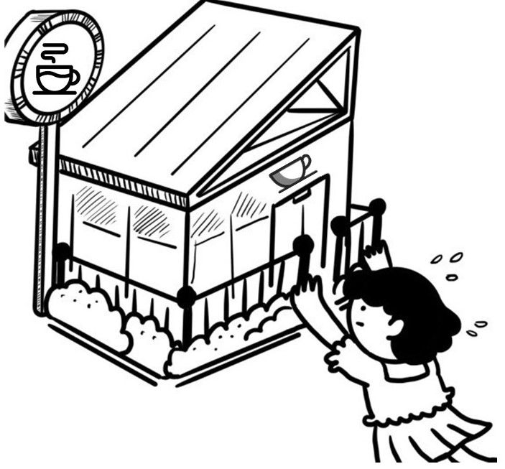

1. Kate wants to see a movie. She is going to a theater.
2. Kate is thirsty and tired. She is going to a coffee shop.
3. Kate wants some pencils and erasers. She is going to a bookstore.
4. Kate would like some stinky tofu. She is going to the night market.

**24.**

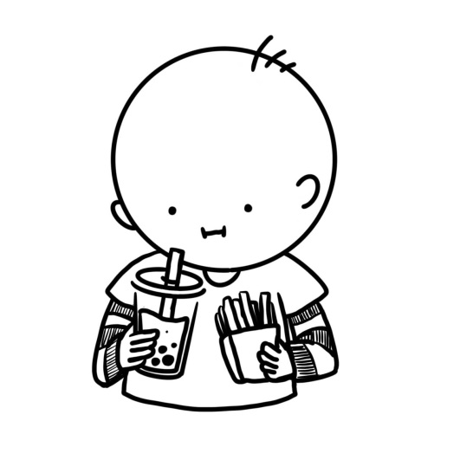

1. Mike is having some fried chicken and orange green tea.
2. Mike is having some French fries and orange green tea.
3. Mike is having some fried chicken and bubble milk tea.
4. Mike is having some French fries and bubble milk tea.

**25.**

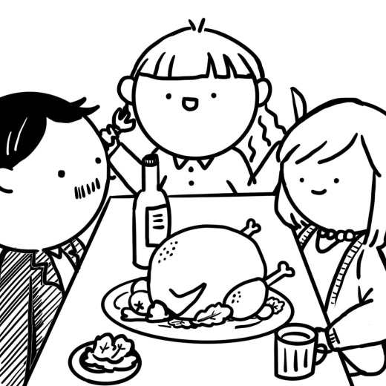

① On Chinese New Year’s Eve, many people have hot pots with their family.

② On Moon Festival, people have BBQ with their family.

③ On Thanksgiving, people have turkey with their family.

④ On Dragon Boat Festival, people have rice dumplings with their family.

**26.**

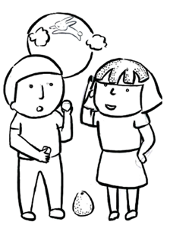

1. There is a Jade Rabbit. We like to eat moon cakes on the festival.
2. There is an Easter bunny. We like to go egg hunting on the festival.
3. There is a reindeer. We like to go to church on the festival.
4. There is a kangaroo. We like to eat pomelos on the festival.

**◆27-29**

|  |
| --- |
| My name is Lisa. I get up at five thirty every morning. I have breakfast with my dad at six. At seven, I go to school on foot.  My best friend, Sandy, is not an early bird. She gets up at seven twenty and goes to school at eight. She is late every day. Our teacher, Ms. Lin, is not happy with that. We have lunch in the classroom at twelve thirty. After school, I play basketball with my classmates. I go home at five, and my dad goes home at six. We have dinner together at six thirty. I do my homework before I take a shower and go to bed at nine. |

**27.** **What time does Lisa go to school?**

1. She goes to school at 7:00.
2. She goes to school at 6:00.
3. She goes to school at 5:30.
4. She goes to school at 7:20.

**28.** **Why is Ms. Lin not happy?**

1. Her student goes to school at seven.
2. Her student goes to school at eight.
3. Her student goes home at five.
4. Her student goes home at eight.

**29.** **What is “an early bird” ?**

1. He / She gets up early.
2. He / She goes to bed early.
3. He/ She gets up late.
4. He/ She goes to bed late.

**◆30-32**

**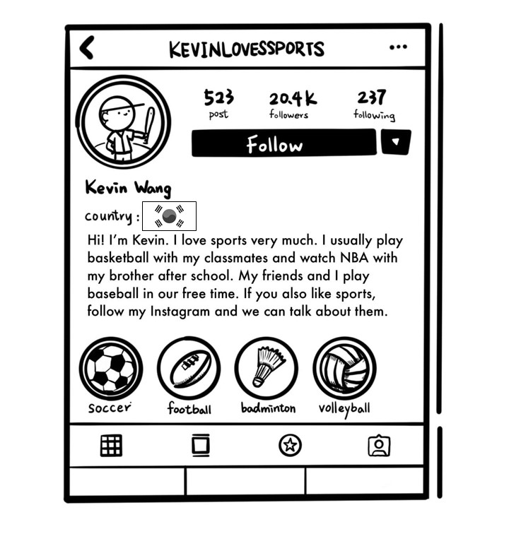**

**30.** **Where is Kevin from?**

① Japan.

② Italy.

③ Korea.

④ Mexico.

**31. What does Kevin do after school with his brother?**

① Playing baseball.

② Playing football.

③ Watching TV.

④ Talking about music.

**32. What’s Kevin’s favorite school subject?**

1. Music.
2. PE.
3. Math.
4. Art.

**◆33-35**

**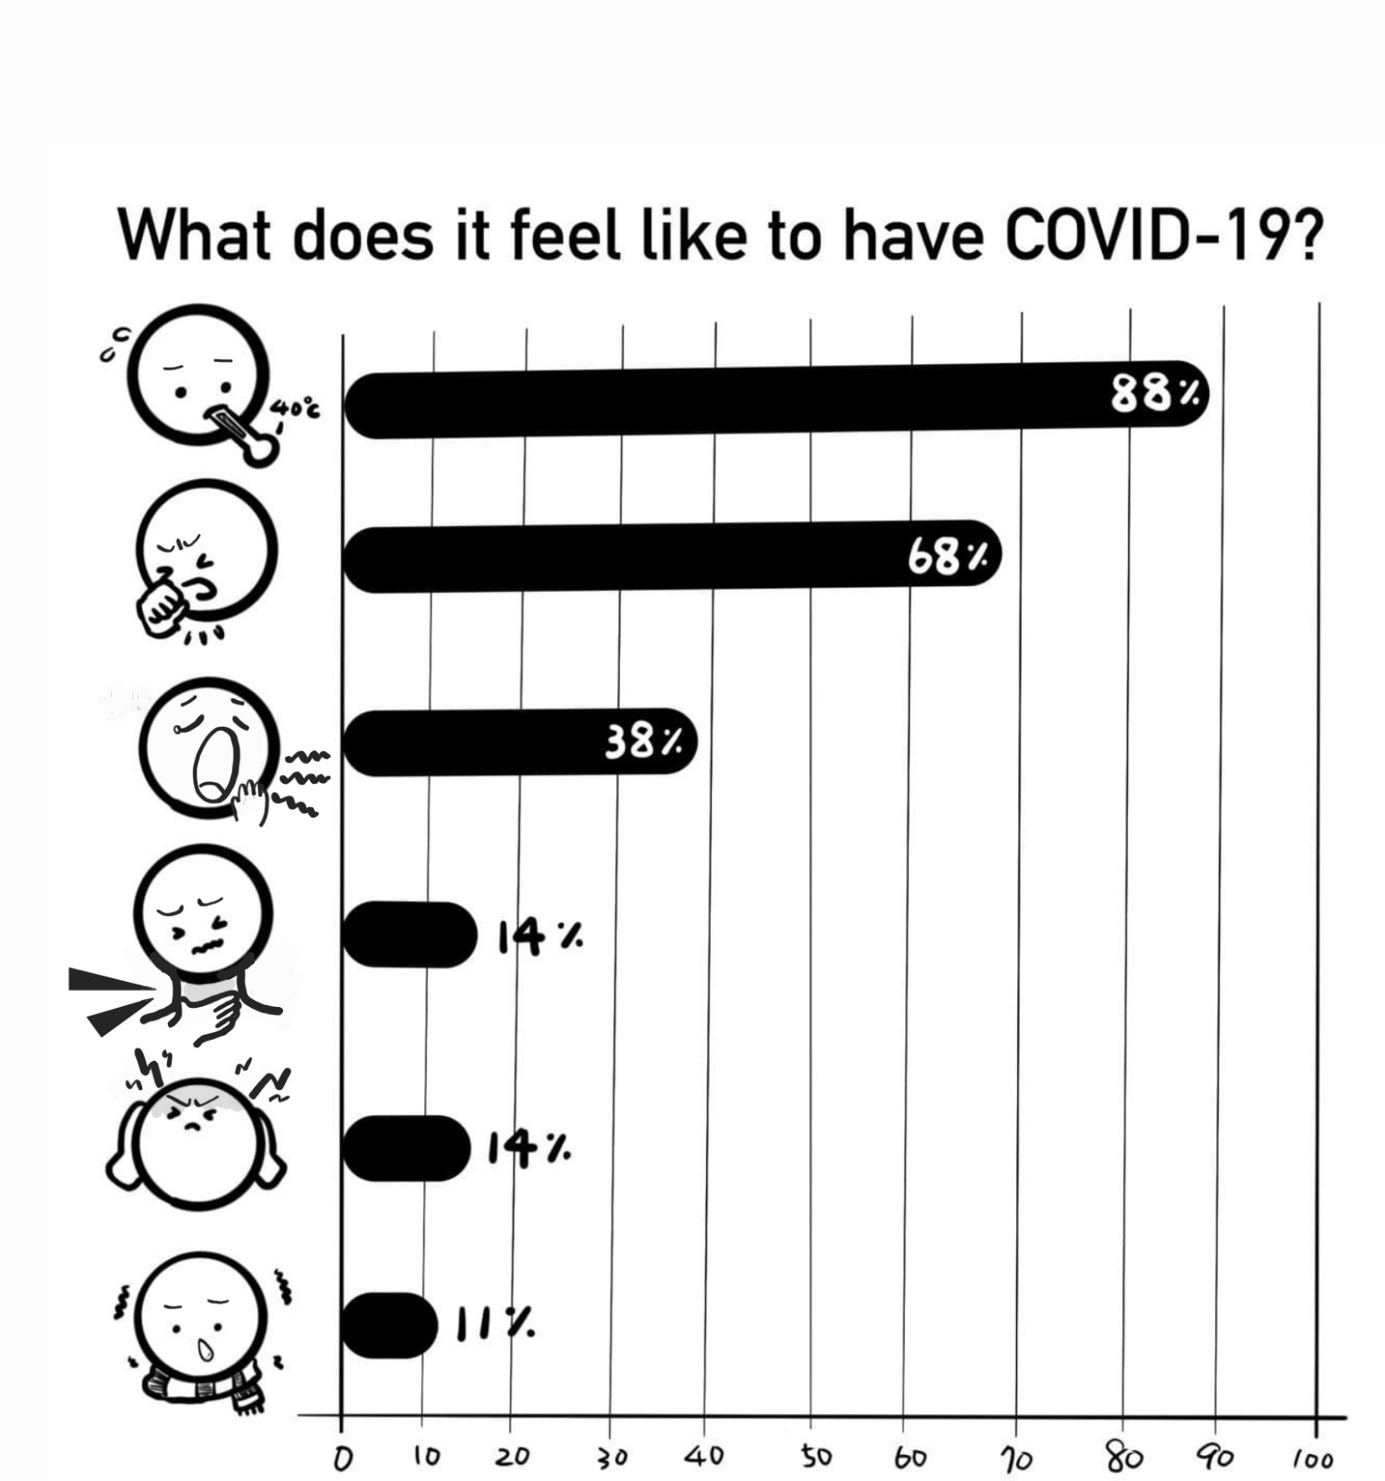**

**33.** **When you get COVID-19, you won’t have a \_\_\_\_\_\_\_.**

① headache

② fever

③ sore throat

④ toothache

**34. Which one is false?**

① Eighty-eight percent (%) of people have a fever.

② Thirty-eight percent (%) of people have a sore throat.

③ Fourteen percent (%) of people have a headache.

④ Eleven percent (%) of people feel cold.

**35. What will you do when you have a fever?**

1. I will go to a library by MRT and study there.
2. I will go shopping at a big supermarket.
3. I will stay at home and don’t go to school.
4. I will have lunch with my friends at a restaurant.